Name: GADDE TEJA SAI
Roll No: AP25110070720
Subject: Data structures
Assignment: Lab Task-1
GitHub Link: https://github.com/tejasaigadde

- Create a structure called "Student'" with members name, age, and total marks. Write a C program to input data for two students, display their information, and find the average of total marks.

CODE:

#include <stdio.h>

struct Student {
char name[50];
int age;
float marks;
};

int main() {
struct Student s[2];
float total = 0, average;
int i;

for (i = 0; i < 2; i++) {
printf("\nEnter details of student %d\n", i + 1);

printf("Name: ");
scanf(" %49[^\n]", s[i].name);

printf("Age: ");
scanf("%d", &s[i].age);

printf("Total Marks: ");
scanf("%f", &s[i].marks);

total += s[i].marks;
}

average = total / 2;

printf("\n--- Student Information ---\n");
for (i = 0; i < 2; i++) {
printf("\nStudent %d", i + 1);
printf("\nName: %s", s[i].name);
printf("\nAge: %d", s[i].age);
printf("\nMarks: %.2f\n", s[i].marks);
}

printf("\nAverage Marks = %.2f\n", average);

return 0;
}
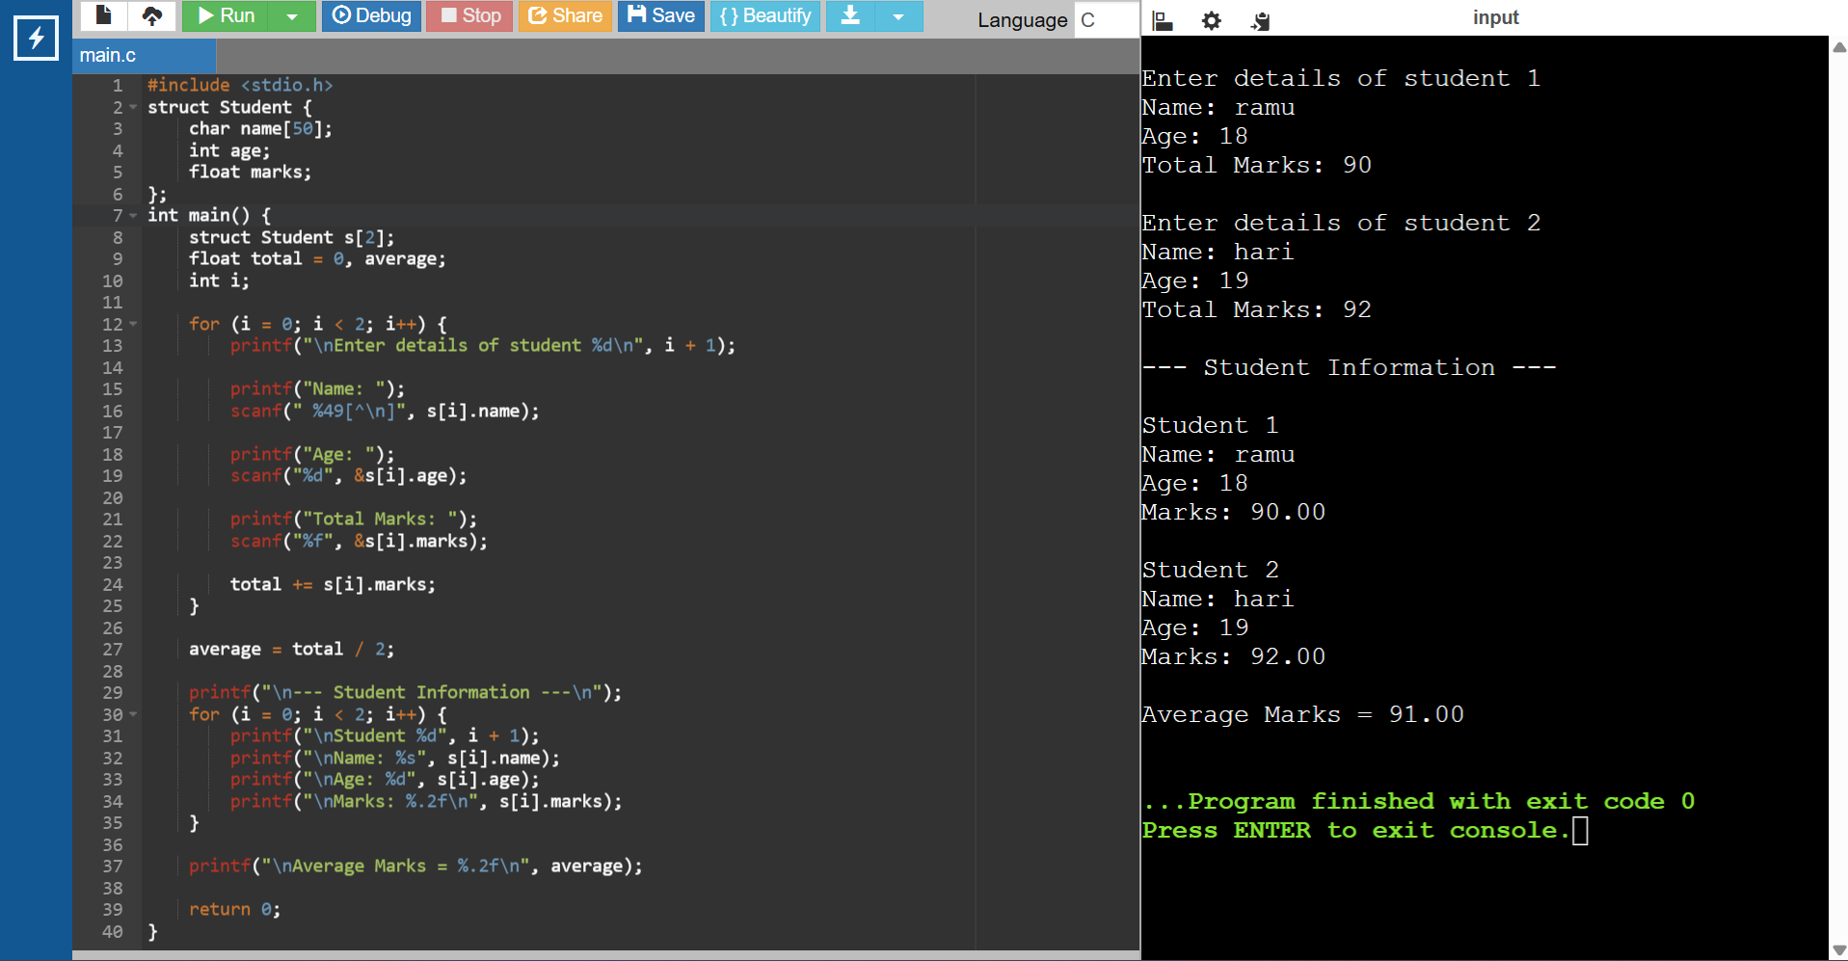

- 1. Design a structure named "Car" to store details like car ID, model, and rental rate per day. Write a C program to input data for three cars, calculate the total rental cost for a specified number of days, and display the results.

CODE:

#include <stdio.h>

struct Car {
int id;
char model[50];
float ratePerDay;
};

int main() {
struct Car c[3];
int days, i;
float totalCost;

for (i = 0; i < 3; i++) {
printf("\nEnter details of car %d\n", i + 1);

printf("Car ID: ");
scanf("%d", &c[i].id);

printf("Model: ");
scanf(" %49[^\n]", c[i].model);

printf("Rate per day: ");
scanf("%f", &c[i].ratePerDay);
}

printf("\nEnter number of rental days: ");
scanf("%d", &days);

printf("\n--- Rental Details ---\n");
for (i = 0; i < 3; i++) {
totalCost = c[i].ratePerDay * days;
printf("\nCar ID: %d", c[i].id);
printf("\nModel: %s", c[i].model);
printf("\nTotal Cost for %d days: %.2f\n", days, totalCost);
}

return 0;
}
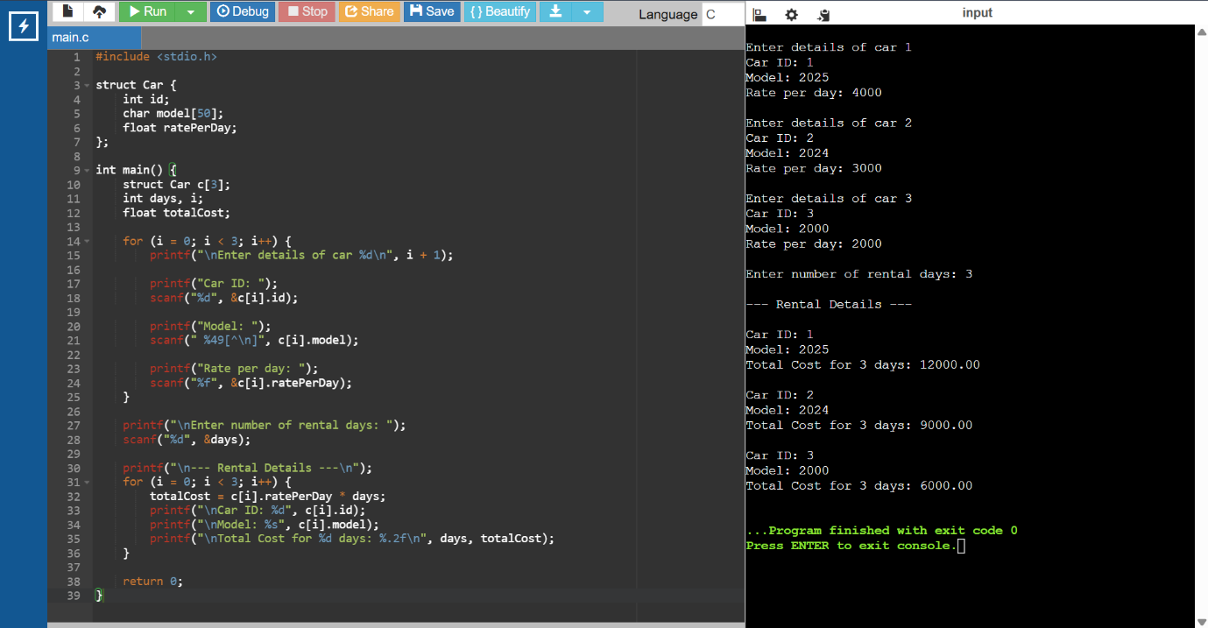

- Create a structure named Complex to represent a complex number with real and imaginary parts. Write a C program to add and multiply two complex numbers.

CODE:
#include <stdio.h>

struct Complex {
float real;
float imag;
};

int main() {
struct Complex c1, c2, sum, product;

printf("Enter first complex number\n");
printf("Real part: ");
scanf("%f", &c1.real);
printf("Imaginary part: ");
scanf("%f", &c1.imag);

printf("\nEnter second complex number\n");
printf("Real part: ");
scanf("%f", &c2.real);
printf("Imaginary part: ");
scanf("%f", &c2.imag);

sum.real = c1.real + c2.real;
sum.imag = c1.imag + c2.imag;

product.real = (c1.real * c2.real) - (c1.imag * c2.imag);
product.imag = (c1.real * c2.imag) + (c1.imag * c2.real);

printf("\nSum = %.2f + %.2fi", sum.real, sum.imag);
printf("\nProduct = %.2f + %.2fi\n", product.real, product.imag);

return 0;
}

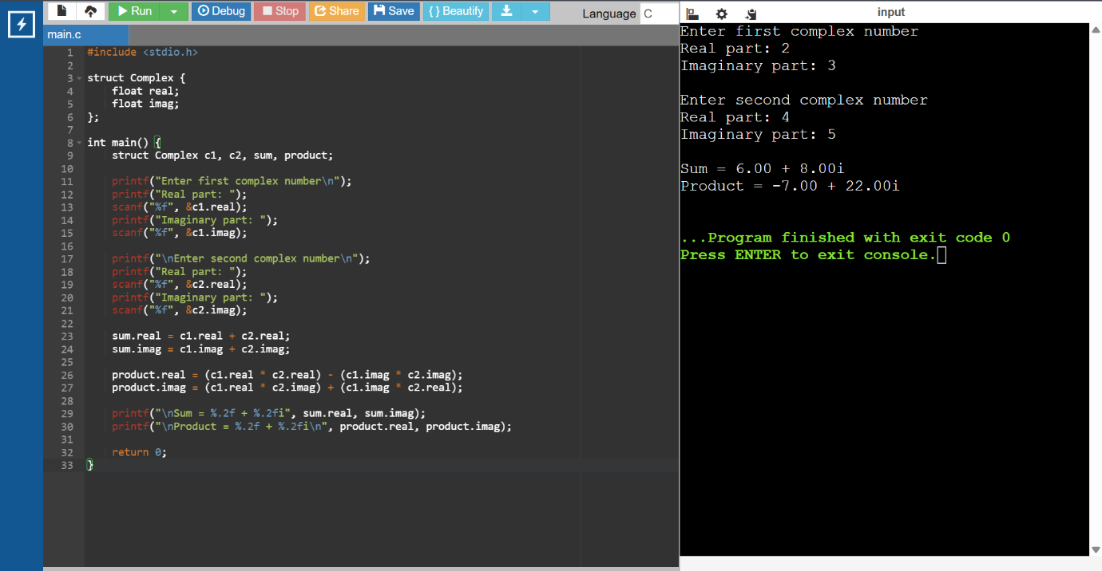

- .Write a program in C to store and print the information of N employees using dynamic memory allocation and structures.
CODE:
#include <stdio.h>
#include <stdlib.h>

struct Employee {
int id;
char name[50];
float salary;
};

int main() {
struct Employee *emp;
int n, i;

printf("Enter number of employees: ");
scanf("%d", &n);

emp = (struct Employee *)malloc(n * sizeof(struct Employee));

if (emp == NULL) {
printf("Memory allocation failed!");
return 1;
}

for (i = 0; i < n; i++) {
printf("\nEnter details of employee %d\n", i + 1);

printf("ID: ");
scanf("%d", &emp[i].id);

printf("Name: ");
scanf(" %49[^\n]", emp[i].name);

printf("Salary: ");
scanf("%f", &emp[i].salary);
}

printf("\n--- Employee Information ---\n");
for (i = 0; i < n; i++) {
printf("\nEmployee %d", i + 1);
printf("\nID: %d", emp[i].id);
printf("\nName: %s", emp[i].name);
printf("\nSalary: %.2f\n", emp[i].salary);
}

free(emp);
return 0;
}

